**1. INTRODUCTION**

Huptions Global, a multinational company, with their headquarters in Madrid is into hotel business in Spain, where they have about 12 percent market share. Huptions Global is willing to establish a hotel in Portugal, the company wish to determine the type of hotel to establish in order to maximize their profit.

Revenue management is the process of optimizing a hotel’s revenue streams by adjusting prices, inventory, and distribution channels based on market demand and other factors(Tal Lavi, 2023). Hotels aim to maximize revenue by increasing sales through various pricing strategies and marketing techniques. Hotels need to find the sweet spot between the price and value they provide to their guests. Though, Huptions Global is still researching on the opportunities that abound in the hotel business in Portugal, It wishes to use the data available to get insights into the present realities of hotel business using business analytics and business intelligence. The dataset showed information about two types of hotels, resort hotels and city hotels. A Resort Hotel is a full-service lodging facility, intended primarily for vacationers and usually located in places frequented for relaxation or recreation, such as beaches, seashores, scenic or historic areas, ski parks, spas(Landman P. 2019). These hotels are designed to offer a wide range of amenities and services to cater to the needs and preferences of tourists and vacationers. Resort hotels can vary significantly in size and style, ranging from boutique resorts to large-scale luxury properties. On the other hand, a city hotel is located in urban areas, usually reserved for people who intend to stay a while (in the short term). City Hotel is also known as a transit hotel because it is usually occupied by business people who use the facilities and business services provided by the hotel (Bedjo 2014). Though there is no reference to pricing in the data available, there are references to variables such as is_repeated_guest, is_cancelled, previous_cancellations, and arrival_date_month, maximizing the output of these variables will definitely increase revenues for Huptions Global subsequently. This report will use Business Intelligence to give recommendations to Huptions Global. Business intelligence (BI) is the use of technology and data analysis to gain insights that inform business decisions. Business intelligence tools can be used to gather, organize and analyze data on customer behaviour, bookings, and revenues generated from different aspects of the business. Insights help managers to make informed decisions about pricing strategies and promotional activities aimed at maximizing revenue. By leveraging Business intelligence tools to uncover patterns and trends in customer behaviour, Huptions Global can adapt to the changing market and remain competitive in the business. Business intelligence will also enable Huptions Global to be proactive rather than reactive, anticipate the needs and preferences of their customers to increase their chances of success, improve their efficiency and ultimately increasing their profitability.

**2. Theoretical Framework**

The hotel industry is a vital sector and offers numerous opportunities for entrepreneurs and investors. The global luxury hotel market size is expected to reach USD 115.80 billion by 2025, according to a report by Grand View Research, Inc. (<https://www.grandviewresearch.com>,2018), registering a 4.3% CAGR(Compound Annual Growth Rate) during the forecast period. The market is expected to grow significantly over the forecast period owing to the increasing purchasing power of consumers and the rising number of international as well as domestic tourists on business or leisure trips. Huptions Global and other investors in the hotel business can generate more revenue by leveraging on the numerous opportunities in the business and also by identifying and tackling the challenges as they appear, thereby retaining previous customers and gaining more prospective ones.

Revenue management is a fundamental objective for hotels seeking to achieve long-term sustainability and profitability in a competitive marketplace. It directly impacts financial performance, investment opportunities, and overall business growth. By effectively optimizing revenue streams, Huptions Global can allocate resources strategically, invest in guest-centric services, and sustain a competitive edge in the industry.

The survival of hotels often depends on their overall financial performance, their ability to adapt to the changing environment, and how they transform and expand their services to meet their customers' needs (Van Niekerk,2016). Technology and data analytics are seen as a transformative force in the business world. As a result, many companies are integrating business intelligence and analytics technology to help with reporting and decision-making (Rikhardsson, P. and Yigitbasioglu, O. 2018).Data-driven decision-making, business intelligence, and analytics (BI&A) have been shown in many researches to be able to prove the companies with a competitive advantage. It is only possible if the business is embracing and using business intelligence and analytics effectively (Jaklič et al ,2018). One of the major challenges in the hotel industry is the cancellation of reservations. And, One of the main ways business intelligence is assisting the industry is through booking optimization. Often, the lifeblood of hotels is the corporate traveller, and being able to consistently book that traveller is key. Booking optimization will be achieved if the variables of the data are optimized, for example, the variable "is_canceled". "is_canceled" is a binary variable that indicates whether a hotel reservation has been canceled or not. It is usually represented as a binary value, where:

- 0 (or "false") indicates that the reservation was not canceled.

- 1 (or "true") indicates that the reservation was canceled.

Another example is the variable lead_time, the time taken between when a customer makes a reservation and their actual arrival is called the Lead Time (Landman, P. 2019). The two factors above and other factors are critical for hotels to manage their operations effectively, optimize revenue, and deliver a better guest experience.

**Business Intelligence Framework**

According to Cintia Esteves de Paulo(2021),Business Intelligence is basically composed of 3 layers:

* Data Source ,
* ETL and
* OLAP.

A short explanation of each of the layers is presented below as explained by Cintia Esteves de Paulo(2021).

**Data Source**

This is where the inputs that will allow the creation of our Business Intelligence are born. As a data source we consider any digital file or information storage structure, which will enable us to generate value for the company. Examples of data sources are: systems registration, such as customers, suppliers, employees, etc, sales systems, service queue control systems, various files (excel, text, xml, csv, etc.). If manual data are collected, they must be entered into an excel file, for example, for consumption by the BI system Cintia Esteves de Paulo(2021). In our case, the data was retrieved from the hotels’ Property Management System (PMS) SQL database. The data is in excel csv format.

**ETL - Data Extraction, Transformation and Loading**

This stage is the core of the BI, and we can subdivide it into 4 steps, which are:

Data Extraction - is the act of submitting specific queries in the data sources, either for the extraction of a complete table (full extraction) or just for a specific period of time (differential extraction). These extractions can comprise all fields in a table, only a subset of fields, or be the result of crossing more than one table.

Data Stage - is the first level of the Data Warehouse database layer. Here, data from all data sources are inserted, in order to make it possible to be within the same technology, to enable the crossing of information. In this layer, the data is recorded as a mirror of the extraction. It is important to note that the tables inserted here are reset to each execution of the ETL processes.

Work Area - this is where we effectively transform the data. Here, we cross information from customers and sales, we equalize data from different sources.

Data Load (Target) - is the last database layer. At this time, the data generated in the work area is loaded into the final model designed for the Data Warehouse. All raw data, processed or generated in the previous layer are loaded or updated for final consumption.

**Data Visualization (OLAP)**

We have reached the tip of the iceberg, where data becomes visible and available for consumption by all business areas. OLAP tools (Microstrategy, Tableau, PowerBI, DataStudio, etc.) connect to the base of the Data Warehouse (target layer) and provide information via dashboards and extractors, so the necessary analyzes are made for decision making by the company's top management. In addition to dashboards, currently, BI systems have the function of providing feedback to transactional systems and generating the enrichment of self-service bases, providing a better customer experience.

**3. DATA COLLECTION AND ANALYSIS**

Data collection and analysis fall in the ETL stage of business intelligence layer. Data collection is the process of collecting, measuring, and analyzing data from various sources to gain insights. Data can be collected through various sources, such as social media monitoring, online tracking, surveys, feedback, etc (Sharma, R. 2022). By collecting data, organizations have a treasure trove of valuable information at their disposal that can be utilized to thrive in today’s competitive market (Sharma, R. 2022).

After data has been collected, we need to analyse the data. Data analysis is the practice of working with data to glean useful information, which can then be used to make informed decisions Coursera(2022).

The data provided by Huptions Global was retrieved from the hotels’ Property Management System (PMS) SQL database. Explanation of each variables is provided by Nuno Antonio et. Al(2018).

The general approach to ETL stage in our case is stated below.

1. The data have so many duplicates. The duplicates were removed.
2. The rows where the number of adults is zero were filtered out, as it is almost impossible for babies and children to lodge in hotel all by themselves.
3. A new column arrival_date was created by combining arrival_year , arrival_month and arrival_day_of_the_week , arrival_day was then extracted from the arrival_date
4. The column “adr” with negative values was filtered out, sinc it is not possible to have a negative ADR

**4. DATA VISUALIZATION**

Dashboard

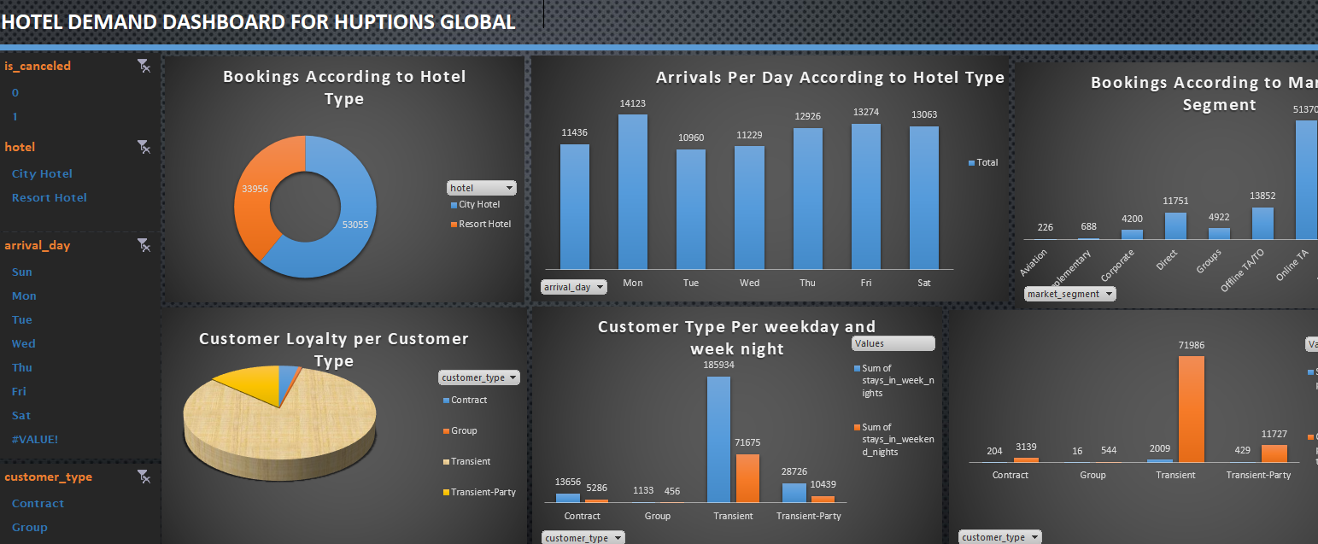

Fig 1: Hotel Demand Dashboard. Showing hotel demand statistics and the slicers.

**JUSTIFICATION FOR USING THE DASHBOARD**

The dashboard shows information about cancelled bookings and the confirmed bookings, arrival day of the week vs hotel type , customer type vs repeated guest. Canceled reservations can have a direct impact on a hotel's revenue. When a guest cancels a reservation, it leaves a vacant room that could have been sold to another guest. As a result, the potential revenue from that room is lost. To maximize revenue, Huptions Global need provide frameworks that will minimize cancellations effectively.

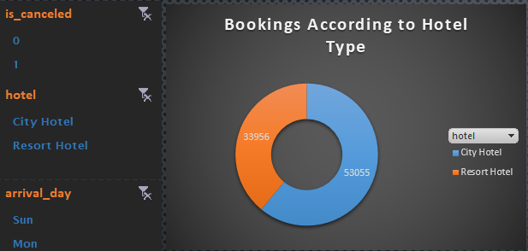

Fig 2:Total number of bookings (both confirmed and cancelled) in city hotels and resort hotels.

This will enable decision makers to see the volume of customers in each hotel type.

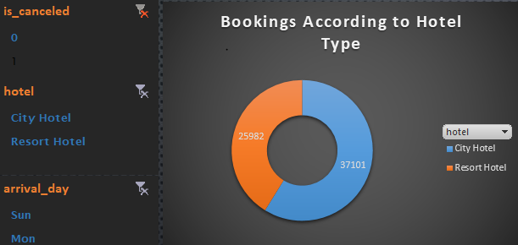

Fig 3: Total Number of confirmed bookings

This will enable decision makers to see the volume of customers that confirmed their bookings in city hote and resort hotel.

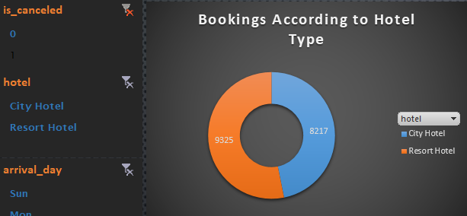

Fig 4: Total number of confirmed bookings in Portugal

This will enable decision makers to see the volume of customers in Portugal that confirmed their bookings in city hotel and resort hotel.

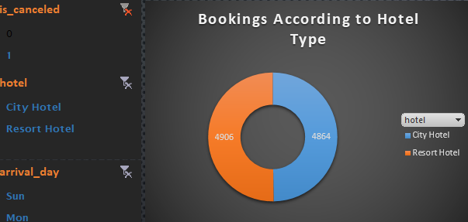

Fig 5 : Total number of cancelled bookings in Portugal

This will enable decision makers to see the volume of customers in Portugal that cancelled their bookings in city hotel and resort hotel.

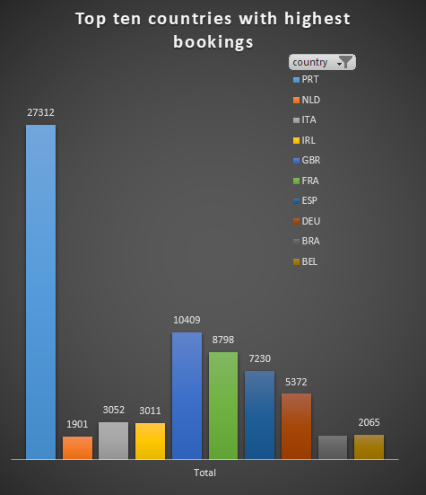

Fig 6: Top ten countries with highest bookings(confirmed and cancelled)

With the chart above, decision makers can view the volume of customers from the top ten countries with the highest bookings. Portugal took the lead, this shows that there is a high volume hotel bookers in portugal. Portugal might be a very good location to site an hotel.

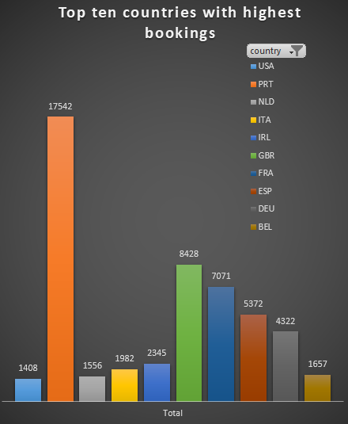

Fig 7: Top ten countries with highest confirmed bookings.

Over sixty four percentage of bookings from portugal are confirmed bookings. This shows the level of loyalty of hotel bookers from Portugal

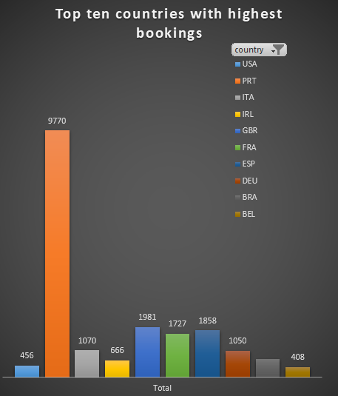

Fig 8: Top ten countries with highest cancelled bookings.

About 35 percent of portuguese hotel bookers cancelled their bookings.

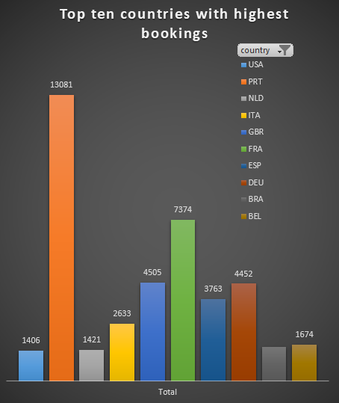

Fig 8: Top ten countries with highets bookings in city hotels.

The top customers of city hotels are Portuguese.

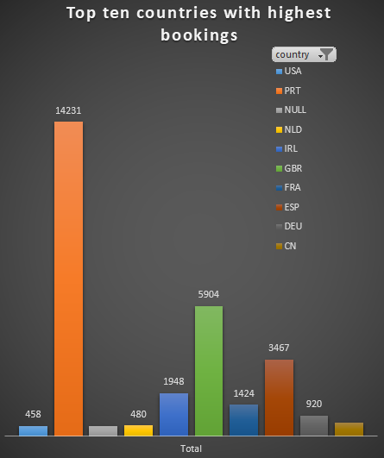

Fig 9:Top ten countries with highest bookings in resort hotels.

Also the top customers of resort hotels are from Portugal .

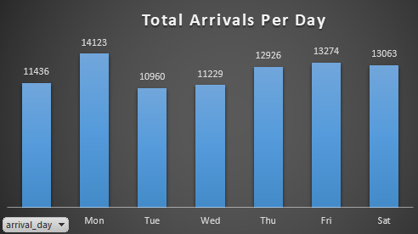

Fig 11: Total arrivals per day from top ten countries

Analyzing total arrivals per weekdays in the top ten countries will enable decision makers to improve occupancy rates, enhance customer satisfaction, and maximize revenue by tailoring their offerings and strategies to meet the unique demands of each day of the week , and to top nationals.

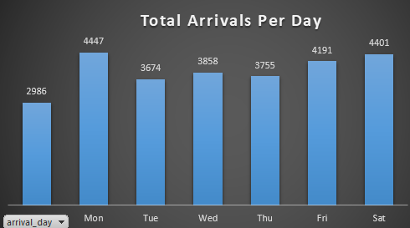

Fig 12: Total arrivals per day from portugal.

With Portugal taking the lead, the increase in arrivals from Portugal could lead to collaborations between hotels and travel agencies, tour operators and airlines from Portugal to provide package deals or special promotions, benefiting the hotels and citizens from Portugal. Special offerings can alsobe tailored to Portugal citizens to attract more of them to possibly spike an increase in arrivals per day from Portugal.

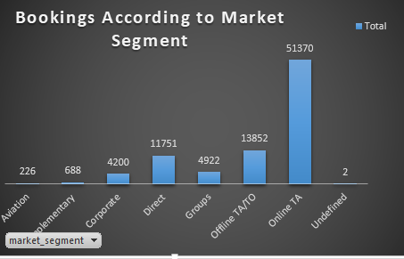

Fig 13: Total bookings according to market segment.

Bookings per market segment refers to how a hotel's bookings are distributed among different customer groups or market segments. Bookings across market segments can provide valuable information into a hotel's customer base and help shape its marketing, pricing, and operational strategies.

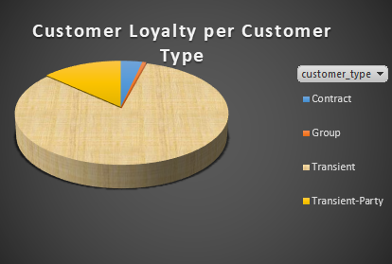

Fg 14: Customer loyalty per customer type.

Customer loyalty and the growth of hotel bookings is a mutually beneficial partnership. When hotels focus on ensuring guest contentment, delivering exceptional experiences, and employing tactics to nurture loyalty, they not only retain their current clientele but also entice fresh patrons. This will contribute to high occupancy rates and increased revenue for the hotels. The chart above show the relationship between customers with previous bookings and customer type. Customer type is talking about the different categories of guests based on various characteristics while a repeated guest is a customer who has previously stayed at the hotel and chooses to return for another stay. Repeated guests are loyal to the hotel and are more likely to make repeat bookings due to positive past experiences. The higher the repeated guest , the better for revenue management. Oppositely, the lower the booking cancellations , the better for revenue management. Understanding the relationship between customer type and repeated guests is critical for revenue maximization. By catering to the needs and preferences of different customer segments and nurturing guest loyalty, Huptions Global can be proactive to increase repeat bookings, boost direct bookings, and implement effective marketing strategies, ultimately have higher revenue and sustainable growth as soon as possible.

**5. RECOMMENDATION**

Business Intelligence (BI) enables the utilization of procedural and technical infrastructure to collect, store and analyze data generated by a company’s activities and presents it in actionable forms like dashboards, reports, charts etc which can be used by the organization to make strategic and tactical business decisions. [Chris Bateson](https://chrisbateson80.medium.com/?source=post_page-----85e9e29b1a94--------------------------------) (2022). Some insights gotten through business intelligence showed that about of 62 percent of customers captured lodged in city hotels, the remaining 38 percent lodged in resort hotel. Looking at the customer type, both city hotels and resort hotels have over 80 percent of transient customers. Considering the volume of customers and customer type, Huptions global can consider setting up a city hotel with a target on the transient customers.. The percentage of bookings cancellations is very high (31 percent) in city hotels compared to a 24% cancellation in resort hotels. Huptions Global should put frame works in place to reduce bookings cancellation.

Reference list

Ahmed, R., Khan, R. and Al-Hassan, A.N. (2019). *(PDF) Business Analytics: A Framework*. [online] ResearchGate. Available at: https://www.researchgate.net/publication/332569572_Business_Analytics_A_Framework [Accessed 29 Jul. 2023].

Bedjo (2014). *Definitions Hotel , Characteristics , Types and Classification of Hotels*. [online] NOT JUST A VISIT. Available at: https://travellio.wordpress.com/2014/02/02/definitions-hotel-characteristics-types-and-classification-of-hotels/ [Accessed 21 Jul. 2023].

Cintia Esteves de Paulo (2021). *The layers that makes a Business Intelligence System*. [online] www.linkedin.com. Available at: https://www.linkedin.com/pulse/layers-makes-business-intelligence-system-c%C3%ADntia-esteves-de-paulo [Accessed 12 Jul. 2023].

Coursera (2022). *What Is Data Analysis? (with Examples)*. [online] Coursera. Available at: https://www.coursera.org/articles/what-is-data-analysis-with-examples [Accessed 12 Jul. 2023].

Jaklič, J., Popovič, A. and Grublješič, T. (2018). *The role of compatibility in predicting business intelligence and analytics use intentions. International Journal of Information Management, 43*. pp.305–318.

Landman, P. (2019). *Xotels*. [online] Hotel Management Company - Hospitality Group - Xotels Ltd. Available at: https://www.xotels.com/en/glossary/resort-hotel [Accessed 20 Jul. 2023].

Lavi, T. (2023). *Understanding Hotel Revenues: Sources, Factors, and Strategies*. [online] Duve. Available at: https://duve.com/hotel-revenue-management-strategies/.

Nuno , A., Maria De Almeida, A. and Nunes, L. (2018). *Hotel booking demand datasets*. [online] Research Gate. Available at: https://www.researchgate.net/publication/329286343_Hotel_booking_demand_datasets [Accessed 9 Jul. 2023].

Rikhardsson, P., & Yigitbasioglu, O. (2018). Business intelligence & analytics in management accounting research: Status and future focus. *International Journal of Accounting Information Systems, 29, 37–58.*.

Sharma, R. (2022). *What is Data Collection? Why is it Important for Your Business*. [online] Emeritus Online Courses. Available at: https://emeritus.org/blog/data-analytics-what-data-collection/ [Accessed 1 Jul. 2023].

www.grandviewresearch.com. (2018). *Luxury Hotel Market Size Worth $115.80 Billion By 2025 | CAGR: 4.3%*. [online] Available at: https://www.grandviewresearch.com/press-release/global-luxury-hotel-market [Accessed 1 Jul. 2023].